

Simply Azerbaijan
4 Nights 5 Days

Itinerary

Day 1

Hotel:
Baku

Meals:
Hotel Port Rivoli (Standard) / Hilton Garden Inn (Value) / Baku Marriott Boulevard (Premium) or Similar in N/A

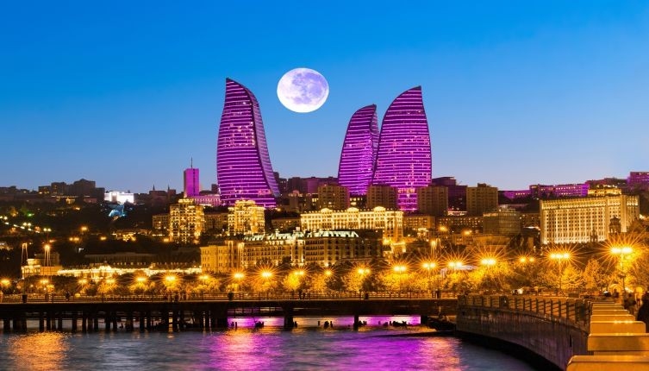
Arrive at Baku

Welcome to Azerbaijan - "The Land of Fire"!

A fascinating country where East meets West, blending rich history, vibrant culture, and stunning landscapes. Known for its eternal flames, ancient traditions, and modern architecture, it offers an unforgettable experience for every traveler. From the Caspian Sea coastline to the majestic Caucasus Mountains, Azerbaijan is a land of contrasts and beauty.

Upon arrival at the Airport, you will be greeted and transferred to your hotel. Enjoy a comfortable ride through Baku's scenic streets, where futuristic skyscrapers stand alongside centuries-old monuments.
Check in at your hotel (standard time approx. 14:00 hrs.) and take some time to relax after your journey.

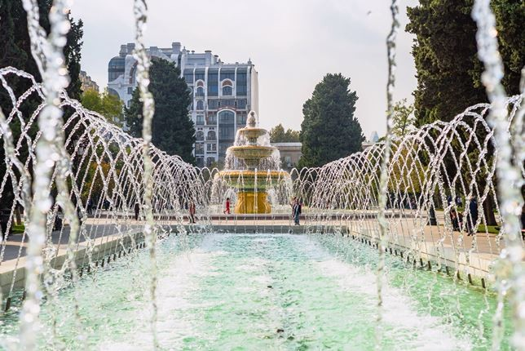
Day 2

Hotel:

Hotel Port Rivoli (Standard) / Hilton Garden Inn (Value) / Baku Marriott Boulevard (Premium) or Similar in

Baku

Meals:

Breakfast

Baku City Tour (PVT basis)

Enjoy Breakfast in Hotel.

Today we proceed to Highland Park, the highest point in Baku, offering panoramic views of the city and the Caspian Sea. Capture the stunning Flame Towers, a modern architectural icon symbolizing Azerbaijan's "Land of Fire," and continue to the National Assembly (Milli Majlis), an impressive landmark showcasing the country's grandeur.

Continue to explore the vibrant heart of Baku, visit the Baku Eye, a giant Ferris wheel with sweeping city views, and stroll along the scenic Boulevard Park. Explore Nizami Street, the bustling shopping avenue lined with boutiques and cafes. Marvel at the futuristic Crystal Hall, then visit the Carpet Museum, celebrating Azerbaijan's rich weaving traditions. Experience the charm of Little Venice, with its serene canals, before stepping back in time at Icheri Sheher (Old City) to discover UNESCO-listed treasures like the Maiden Tower and the Palace of the Shirvanshahs, each echoing centuries of history.

Day 3

Hotel:
Baku

Meals:
Hotel Port Rivoli (Standard) / Hilton Garden Inn (Value) / Baku Marriott Boulevard (Premium) or Similar in Breakfast

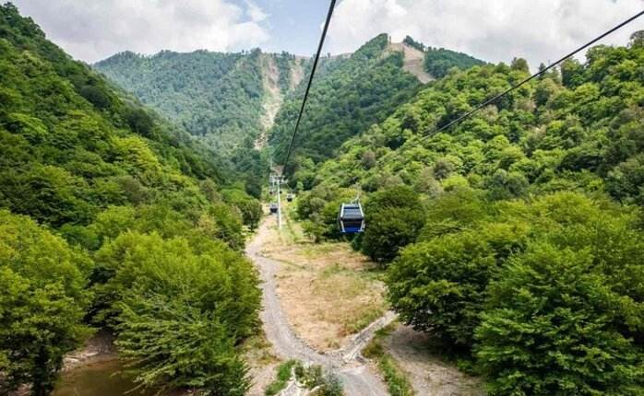
Baku - Gabala Tour - Baku
Enjoy Breakfast in Hotel.
Escape the city and experience the natural beauty of Gabala, a picturesque region surrounded by the Caucasus Mountains. Proceed to Nohur Lake, a serene spot perfect for relaxation and photography. Continue to the stunning Yeddi Gozel Waterfall (Seven Beauties), where cascading waters create a magical setting amidst lush greenery.
Enjoy a thrilling ride on the Cable Car, offering breathtaking panoramic views of Gabala's mountains and valleys

Day 4

Hotel:
Baku

Meals:
Hotel Port Rivoli (Standard) / Hilton Garden Inn (Value) / Baku Marriott Boulevard (Premium) or Similar in Breakfast

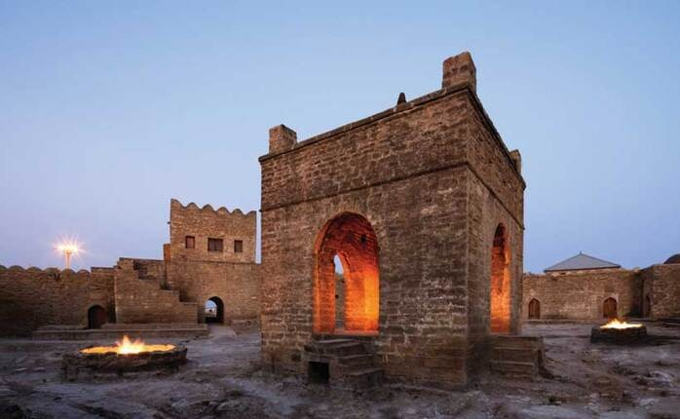
Ateshgah and Gobustan Tour

Enjoy Breakfast in Hotel.

Proceed to the historic Ateshgah Fire Temple, a unique 17th-century sanctuary once used by Hindu and Zoroastrian worshippers, showcasing Azerbaijan's spiritual heritage. Continue to the mesmerizing Yanardag (Fire Mountain), where natural flames blaze eternally on the hillside - a true symbol of the "Land of Fire." Next, admire the architectural brilliance of the Heydar Aliyev Center, an iconic masterpiece by Zaha Hadid, followed by a visit to the Vintage Car Museum, featuring classic automobiles that reflect elegance and engineering.

Later, head towards Gobustan National Park, famous for its ancient rock petroglyphs, a UNESCO World Heritage Site that tells stories from thousands of years ago. Experience the fascinating Mud Volcanoes, a natural wonder unique to Azerbaijan, and enjoy a thrilling ride in a classic Lada car, adding a touch of adventure to your day.

Day 5

Hotel: Meals:

N/A Breakfast

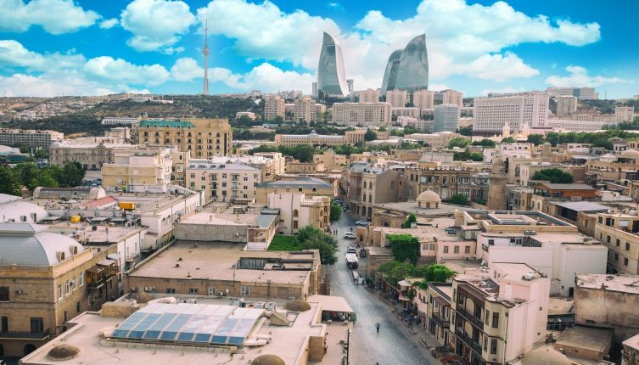
Departure
Morning after breakfast; you will be transferred to the airport for your flight back home to India

* The itinerary is tentative and subjected to change without prior notice.

Hotels Envisaged

Standard
City | Hotel Name | Category
Baku | Hotel Port Rivoli / Similar | 3 star

Meals
Daily Breakfast except on Day 01

Inclusions
- 04 night's stay at the selected hotel option or similar in Baku
- Daily breakfast, except on Day 1
- Visa charges
- Return Airport transfers
- Panoramic and Baku city tour
- Baku City Tour
- Gabala tour from Baku
- Ateshgah and Gobustan Tour
- All sightseeing using air-conditioned transportation (PVT basis) (Sedan, Vito, Mercedes Sprinter or similar)
- Entrances fees (Funicular Ride, Fire Temple, Fire Mountain, Mud Volcano, Rock Museum, Cable Car-Gabala)
- Travel Insurance (Valid till the age of 60 Yrs.)

Visa
- E Visa is Included

- Cost of Visa and Insurance for Duration of the tour is included

Passport
- Passport should be valid for 6 months from the date of departure

Exclusions

- TCS and GST
- Departure PCR test, if applicable
- All flights services
- Meals not mentioned in the itinerary
- Any tips (Around USD 05.00 per person / per day) - for guide and Driver
- Any other sightseeing entrance fees except for the ones mentioned in the Inclusions
- Anything not mentioned in the inclusions
- Pre and Post tour services and cost
- Expenditure of personal nature (Such as use of Mini - Bar and Refrigerator, laundry service, telephone call, camera fee, tips and etc.)
- All drink and beverages
- Hotel promotional rates not valid during Black out Period / Surcharge Dates / Stop Sales on Hotel
- Tourism Tax (if applicable)
- Midnight surcharge
- The rates are valid for a minimum of 01 adults travelling.
- Blackout Dates: 13 Mar - 27 Mar'26, 11 May - 25 May 26, 11 Sep - 25 Sep'26 and 15 Dec'26 - 05 Jan'27
- The above prices will not be valid for any black out date/ Stop sale period which is informed during confirmation of the booking; if any change in the price, the same will be applicable for all bookings and to be borne by the customer

Product Terms & Conditions

Terms And Conditions
- The hotel upgrade prices are subject to availability at the time of booking.
- The hotel upgrade prices DO NOT GUARANTEE rooms at the envisaged hotels.
- The upgraded hotel rooms are subject to availability at the time of booking.
- For the Hotel Upgrade, in case the hotel chosen is unavailable, we will provide multiple options of similar category hotels.

The rates are valid for a minimum of 01 adults travelling.
- The rates are not valid on block out dates.
- Surcharges as and when applicable will be advised and passengers would be requested to pay the same
- Surcharges could be over and above the total package price quoted to the passengers at the time of booking.
- Guests are requested to check with sales staff before booking their onwards/connecting flights.
- The rates are subject to availability of hotel accommodation and sightseeing tours at the time of booking. We reserve the right to use an alternate hotel accommodation of an equal or higher standard. If we source a more expensive alternative, we reserve the right to re-quote based on the higher rates.
- Prices are not valid during Trade Fair periods.
- Rates are valid for Indian Passport holders only.
- International Check in time is 1400 hours / Check out time is 1100 hours, early check in and checkout is subject to availability and cannot be guaranteed.
- Transfers wherever included are without night surcharges.
- No refunds either in part or in full will be made for any unutilized service.
- All the sightseeing tours and excursions are organized by local companies. The timings and days of operation are subject to alteration. Changes if any will be intimated at the time of booking.
- Sightseeing tours are strictly based on whether conditions and also local service providers have the right to cancel the sightseeing tours without prior notice.

- Rates subject to change without prior notice and also for clients traveling during weekends.
- Offer if any can be withdrawn at any point without prior notice.
- Bookings once confirmed are subject to cancellation charges which shall be advised at that time.
- TCIL is not responsible for any change in the price due to factors not in the control of the organization.
- As a practice, all international hotels charge a security deposit via credit card or cash, at the time of check-in for each room. The amount will vary according to the hotel and is refunded back to the clients upon check-out. Debit cards should not be offered as they will be charged immediately and refunded only after 2-3 weeks. If any additional services or mini bar or any other service is utilized at the hotel, the hotel reserves the right to charge the same on this security deposit provided by the client. TCIL would not be responsible for these transactions, and these are solely between the hotels and the clients.

Terms and Conditions
For Terms and Conditions please refer to the below link.

